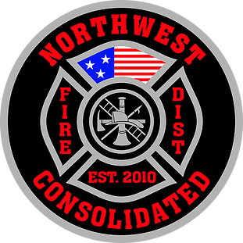

Northwest Consolidated Fire District
Serving De Soto & Northwest Johnson County, Kansas

JOB ANNOUNCEMENT
February 25, 2020
Initial Interviews Will Occur During the Week of March 23, 2020

Job Title: Firefighter/EMT

NWCFD is establishing a hiring eligibility list for anticipated Firefighter/EMT position openings. Firefighters perform duties related to fire prevention, suppression, hazardous material incidents, emergency rescue, basic life support, and first aid under emergency conditions frequently involving considerable danger. Employees in this classification work under the direct supervision of a company officer.

NWCFD offers a competitive benefit package including a health, dental, and vision insurance plan, health reimbursement account (HRA), Kansas Police and Fire (KP&F) defined-benefit Retirement System, eligibility to voluntarily participate in the supplemental State of Kansas KPERS 457 deferred compensation plan, paid vacation leave, paid sick leave, paid personal leave, paid holidays (x2.0 of regular wages on holidays worked; 12 hours on holidays not worked), and paid bereavement leave. Firefighters work a modified Berkeley shift schedule of alternating days of 24 hours on-duty and 24 hours off-duty for a total of three-shift days over five days, followed by four days off. Firefighters are compensated with an overtime rate in accordance of the FLSA Section 7(k) exemption.

Annual Earnings (Base; Excluding Overtime & Benefit Package):
- $38,195 (Starting)
- $39,341 (Post-Probation in 1st Year)
- Lateral pay will be considered for qualified candidates with previous full-time experience

MINIMUM QUALIFICATIONS

- Must be 20 years or older
- Must possess a valid driver’s license with a safe driving record
- High School Diploma or equivalent
- Firefighter I and II certifications
- Current Kansas or National EMT certification
- Current Candidate Physical Ability Test (CPAT) certification
- Written Fire Service Entrance Exam (FSEE) with a score of 70 percent or better within the past two years
- The ability to pass a post-offer physical, drug screen, and background investigation

NWCFD Employment Application and copies of certifications, CPAT, and FSEE results must be included to be considered as a qualified candidate. Please submit all documents along with a NWCFD Employment Application (available at the address below or online at www.nwcfd.org) via mail or in-person at:

Northwest Consolidated Fire District
9745 Kill Creek Rd.
De Soto, KS 66018

Questions can be directed to Battalion Chief Brandon Shipman at (913) 585-0077 (M-F 8 a.m. - 5 p.m.).

An Equal Opportunity Employer

